Medical Identity Theft

What is medical identity theft?

Medical identity theft is when someone fraudulently gets and uses your personal information, like your:
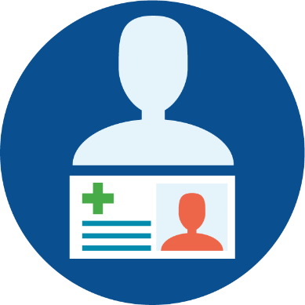
- Name
- Medicare number
- Social Security number
- Driver’s license number
- Address
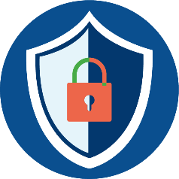
To then use this information to:
- Get medical treatment
- Buy medical equipment
- Get prescriptions
- Submit claims to your health insurance for items you don’t need, request, or may have never received.

How to protect yourself from medical identity theft

- Be careful about who you give your personal information to.
- Never give out your Medicare number to anyone who contacts you through unexpected or unknown calls, texts, or emails. Remember that Medicare and Social Security will never reach out to you to ask for your personal information.
- Keep documents that contain your medical information somewhere safe.
- When getting rid of these documents, shred them or wait for a local shred day.
- Look out for common fraud schemes used to steal personal information.
  - This includes scams offering “free” COVID-19 tests, back or knee braces you didn’t ask for, genetic testing, cancer screening kits, “new” Medicare cards, and telehealth.
Medical Identity Theft

Identify the signs of medical identity theft

If someone steals and then uses your medical information, be on the lookout for:
- Charges and providers on your Medicare statements that you don’t recognize
- Shipments of back or knee braces, testing kits, or other medical supplies that you didn’t ask for
- Contact from a debt collection company for a provider bill that you don’t owe
- Medicare and/or your Medicare Advantage (MA) plan denies or limits your coverage or benefits because of a medical condition you do not have or says you already received a product or service when you did not

Report medical identity theft

If you believe someone has stolen your medical information, contact your local Senior Medicare Patrol (SMP). Your SMP will encourage you to:
- Review your Medicare statements for any additional concerns
- Get copies of your medical records from providers the scammer may have used
- Review your credit reports
- Report any errors on medical records or statements to your providers and your compromised number to Medicare, 1-800-Medicare (633-4227) or your MA plan
- If you gave out your Social Security number, report it to Social Security and make a recovery plan using the Federal Trade Commission’s tips at www.IdentityTheft.org


Contact your Senior Medicare Patrol (SMP) to report medical identity theft!
Visit www.smpresource.org or call 877-808-2468.

Medical Identity Theft


Who to contact for more information:

- Senior Medicare Patrol (SMP): Contact your local SMP if you believe your medical information has been compromised.

- State Health Insurance Assistance Program (SHIP): Contact your local SHIP if you have other questions about your Medicare health coverage.

Local SHIP contact information | Local SMP contact information
SHIP toll-free: 800-247-4422 | SMP toll-free:
SHIP email: IdahoSHIBA@doi.idaho.gov | SMP email:
SHIP website: https://doi.idaho.gov/SHIBA/ | SMP website:
To find a SHIP in another state:  Call 877-839-2675 (and say “Medicare”  when prompted) or visit www.shiphelp.org | To find an SMP in another state:  Call 877-808-2468 or visit www.smpresource.org
SHIP Technical Assistance Center: 877-839-2675 | www.shiphelp.org | info@shiphelp.org
SMP Resource Center: 877-808-2468 | www.smpresource.org | info@smpresource.org
© 2025 Medicare Rights Center | www.medicareinteractive.org
The Medicare Rights Center is the author of portions of the content in these materials but is not responsible for any content not authored by the Medicare Rights Center. This document is supported by the Administration for Community Living (ACL), U.S. Department of Health and Human Services (HHS) as part of a financial assistance award totaling $3,000,000 with 100 percent funding by ACL/HHS. The contents are those of the author(s) and do not necessarily represent the official views of, nor an endorsement, by ACL/HHS, or the U.S. government.

